90%
This hands-on test is an individual assessment meaning you may not get assistance from your instructor or other classmates. You may use your textbook, labs and lecture notes.
All code submitted must be your original work. Code must be committed and pushed to your git repository inside the HOT1 folder to receive credit.

Implement both exercises in one Visual Studio project with working links between 2 pages. -10pts

HomeController and Layout file are optional for this test only.

DistanceConverter
Write a program that converts distances between inches and centimeters.
- Prompt the user for a distance in inches.
- When the user submits the form, display the distance in both inches and centimeters as follows:
“2.00 inches is 5.08 centimeters”
- See rubric on next page for more details.

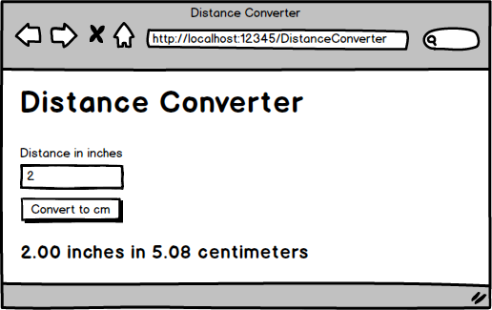

DistanceConverter Rubric [40 pts]

Model &[10 pts]
- Model Creation: A model is created and used for the page.
- Required Field & Validation: The distance field is required, must be between 1 and 500, and has a custom validation message.
- Correct Conversion: The correctly converts inches to centimeters.

Controller [9 pts]
- Action Method Attributes: The [HttpGet] and [HttpPost] attributes are correctly applied to the action methods.
- Model Validation Check: The POST action method checks if the model is valid before doing any calculations.

View [5 pts]
- Error Message Display: Correct error messages are displayed in red only when appropriate.

Tailwind Styling [16 pts]
- Tailwind Integration: The latest version of Tailwind is implemented.
- Navbar: A collapsible Navbar is implemented.
- Labels: Labels are used to associate text boxes with their labels.
- Error Message Styling: Display error messages in red
- Form Controls: Tailwind classes are applied to all form controls
- Button Styling: Tailwind classes are applied to the button.
- Margins: Margins are used to make the form look more professional.
OrderForm
Create a program for ordering T-Shirts.
- Users must enter a quantity.
- Users can enter an optional discount code.
- Shirts are normally $15 each. Sales tax is 8%.
- If the discount code is valid, then apply the relevant discount.
- If the discount code is not valid, then display an error message and calculate the receipt without a discount
- See rubric on next page for more details.

Discount Code | Discount Percentage
6175 | 30% off
1390 | 20% off
BB88 | 10% off

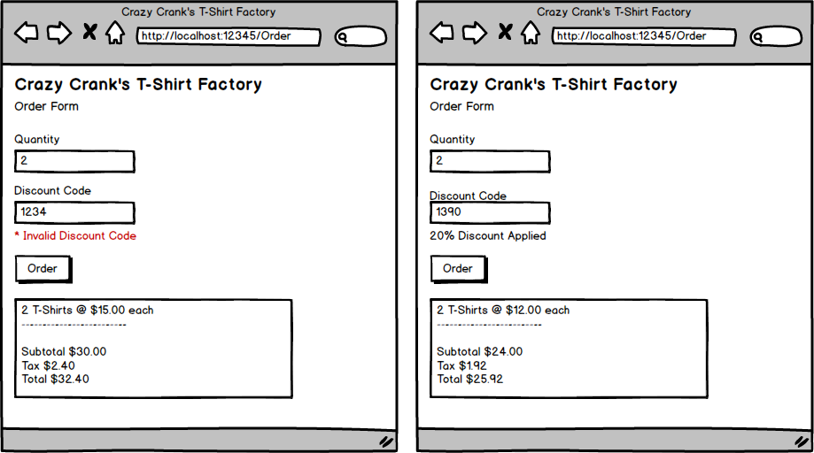

OrderForm Rubric [50 pts]

Model [20 pts]
- Model Creation: A model class is created and used.
- Required Field & Validation: The quantity field is required and has a custom error message.
- Error Message Display: The view displays the custom validation message from the model.
- Correct Calculations: Subtotal, tax, and total are calculated correctly.
  - The base cost for each shirt is $15.
  - Sales tax is 8%.
- Discount Application: A valid discount code is correctly applied to the shirt cost.
  - 6175 is a 30% discount.
  - 1390 is a 20% discount.
  - BB88 is a 10% discount.

Controller [8 pts]
- Action Method Attributes: The [HttpGet] and [HttpPost] attributes are correctly applied to the action methods.
- Model Validation Check: The POST action method checks if the model is valid before doing any calculations.

View [10 pts]
- Error Message Display: Error messages are displayed in red only when appropriate.
- Monetary Formatting: All monetary amounts are formatted as currency (e.g., $15.00).

Tailwind Styling [12 pts]
- Navbar: A collapsible Navbar is implemented.
- Labels: Labels are used to associate text boxes with their labels.
- Error Message Styling: Display error messages in red
- Form Controls: Tailwind classes are applied to all form controls
- Button Styling: Tailwind classes are applied to the button.
- Margins: Margins are used to make the form look more professional.

